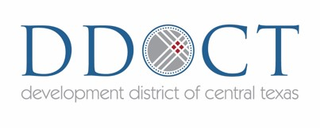

Board of Directors Meeting
Central Texas Council of Governments Building
2180 North Main Street, Belton, Texas 76513

Thursday, October 8, 2020
9:30am
Please join meeting from your computer, tablet or smartphone.
https://global.gotomeeting.com/join/484573789
You can also dial in using your phone.
United States: +1 (872) 240-3311
Access Code: 484-573-789
Agenda
- Call to Order by Kara Clore, Chairman of the Board.

- Public Comments.

- Staff Update: Update on CTCOG planning grants and activities.

- Discussion and Action Item: Regarding minutes of the July 9, 2020 Board Meeting.

- Discussion and Action Item: Regarding election of new officers for FY21.

- Discussion and Action Item: Update on the 2020 Leadership Central Texas Program.

- Discussion Item: Update from the Office of the Governor.

- Discussion Item: Update from the Economic Development Administration.

- Discussion Item: Update on Regional Broadband Initiatives.

- Discussion Item: Other grant opportunities.

- Board of Directors' Comments.

- Discussion of agenda items for next meeting on January 7, 2021 at 9:30am.

- Adjourn.

The Development District of Central Texas is committed to compliance with the Americans with Disabilities Act (ADA). Reasonable accommodations and equal opportunity for effective communications will be provided upon request. Please contact the DDOCT office (254-770-2200) 24-hours in advance if accommodation is needed.
Citizens who desire to address the board on any matter may sign up to do so prior to this meeting. Public comments will be received during this portion of the meeting and will be limited to no more than three (3) minutes.

